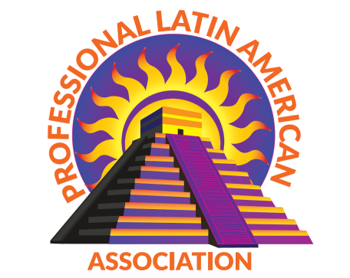

Professional Latin American Association
229 N. Douty Street, Hanford, Ca. 93230
P 559-582-7515 Fax 584-3531
Email: plaakings@yahoo.com Website: www.plaa-kings.org
Non-profit #582584776

^{7th} ANNUAL
TACO TRUCK THROWDOWN
FUNDRAISER
May 21st 2022
Taco Truck Application & Rules

Event:
The Professional Latin American Association will host the 7th Annual Taco Truck Throw Down on Saturday May 21st, 2022 from 5pm to 10pm in downtown Hanford, CA. This event is a scholarship fundraiser to raise funds for graduating students. The event will be a competition amongst Taco Trucks facing off for “Judges Choice” “People’s Choice” and “Best of Show” trophies.

- VIP Judges Choice – Votes for THE BEST TACOS (Announced at 8 pm)

- Best of show – BEST LOOKING TACO TRUCK (Announced at 8:30 pm)

- People’s Choice – TACO TRUCK THAT SELLS THE MOST TACOS (Announced at 9:30 pm)

Rules for Participation:

In order to participate in the event each Taco Truck must submit this application and must abide by any and all health codes for the City of Hanford. Each Taco Truck is responsible for maintaining their own license to practice business, provide own lighting and is responsible to abide by all rules set forth in this document.
- There is a $150.00 application buy-in fee to participate in the event for every Taco Truck. The fee includes the $100 entry fee and $50 secure fee for your participation in the event. Cancellations will not be refunded
- Each Taco Truck will ONLY sell tacos the day of the event. Taco Sales reimbursements will be done in form of a check, for accountability and bookkeeping purposes. ________________ Initial
- Taco Trucks must obtain their Business License from Hanford City Department & Food Permit from Hanford Health Department. _______________ Initial
- A reminder that this is a FUNDRAISER, so profits will be divided with 25% going to PLAA for the entire evening and 75% to Taco Truck.
Rules during the Event:
- Taco Truck staff must conduct themselves in a professional and courteous manner.
- Taco Truck staff is responsible for keeping their area clean and must clean up their area when event is over.

My entry fee is NOT refundable and you will be disqualified if found in violation of the rules listed. Initials ________________

*Our PLAA staff will conduct inspection of your area after the event.*

TACO TRUCK APPLICATION

(Do not complete this application if you are not a taco truck participant)

Application will not be complete without verification of your paid license city permit and food vending permit.

Participant Information:

Taco Truck Name: __________________________________________________

Owner/Operator Name: Business License No.

Contact Address:

Phone # Size of truck:

Email:________________________________________________________________

Check to be made payable to:__________________________________________________________

**SET UP & ENTRANCE TIME IS 3 PM (entrance details to follow)**

By signing below I am agreeing to the rules of the 7th Annual Taco Truck Throw Down. I understand that I am responsible for my own set-up and clean-up. If found in violation of any rules listed above, I will be disqualified.

Signature Date

“OFFICE USE ONLY*

Date Received: __________ Amt. Paid __________ Check # ____________ Cash □
Food Vending Permit Application □ License Fee □

Last edited 12/10

